New Project

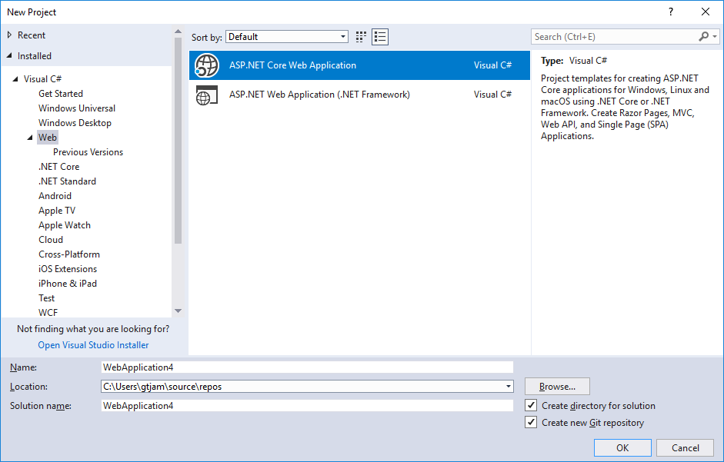

Name it whatever you like

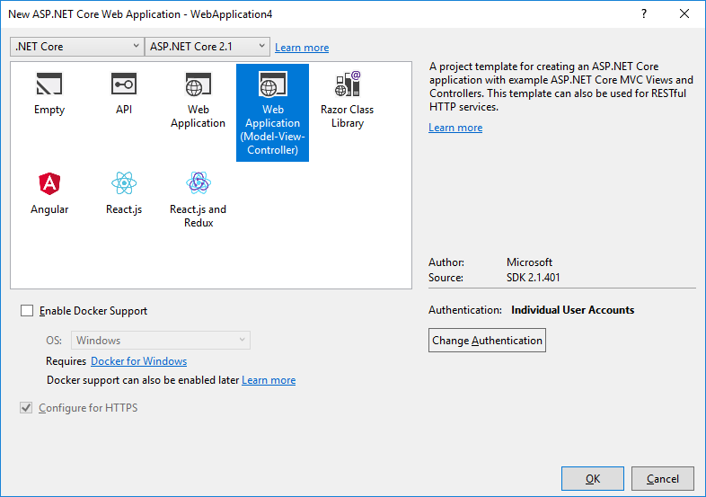

Specify that this will be a Web MVC application

Click the Change Authentication button

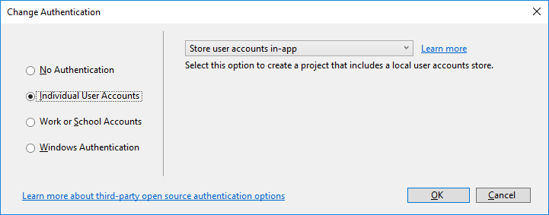

Chose the Individual User Accounts option.

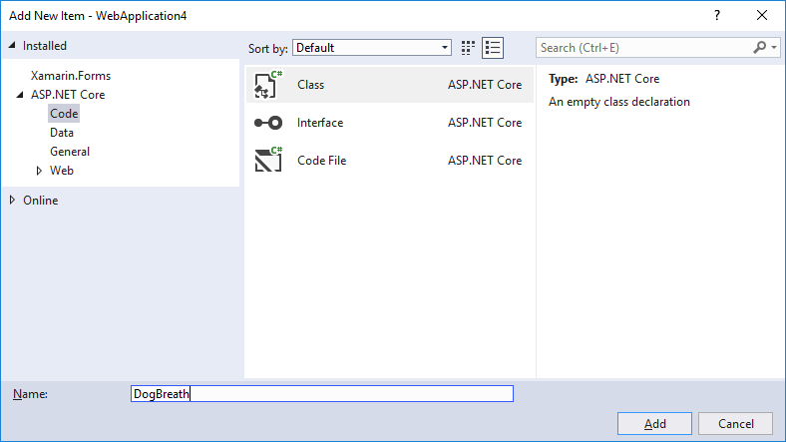

Let’s create a class that will be our records in the database. Right Click Model, click Add, Click Class.

This is the POCO we will model our database on.

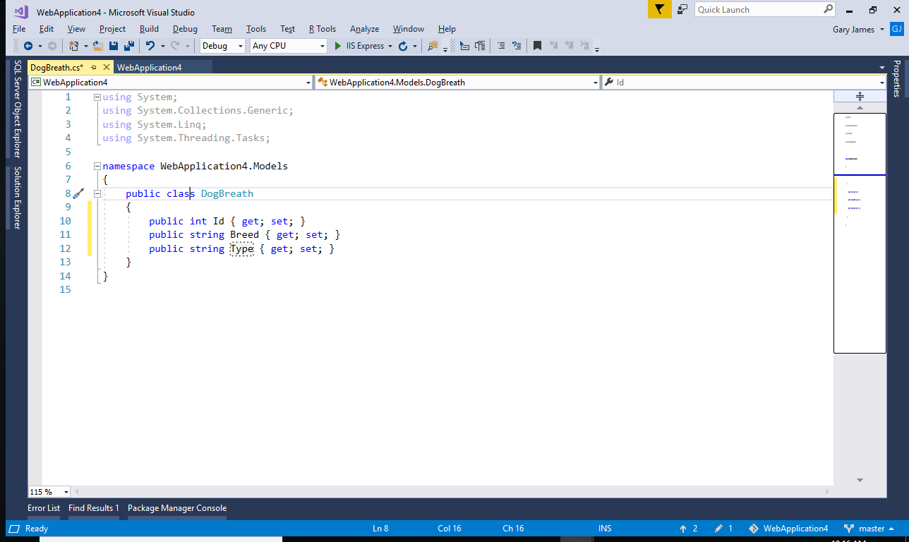

Now create a Controller. Right click on the Controllers folder, click Add then click Controller

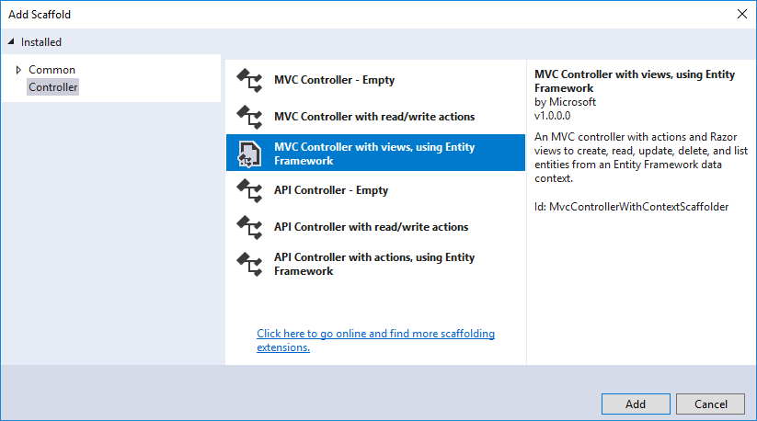

This Controller will be based on our POCO we just created.

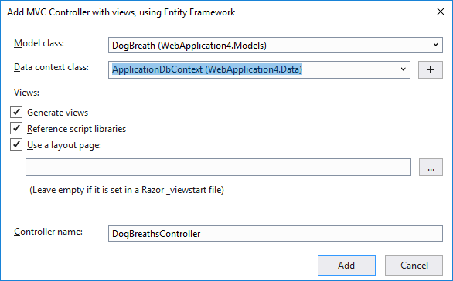

We want to get to our Controller web pages quickly so we will add a link to the nav bar which is found in the _Layout.cshtml page in the Views/Shared folder

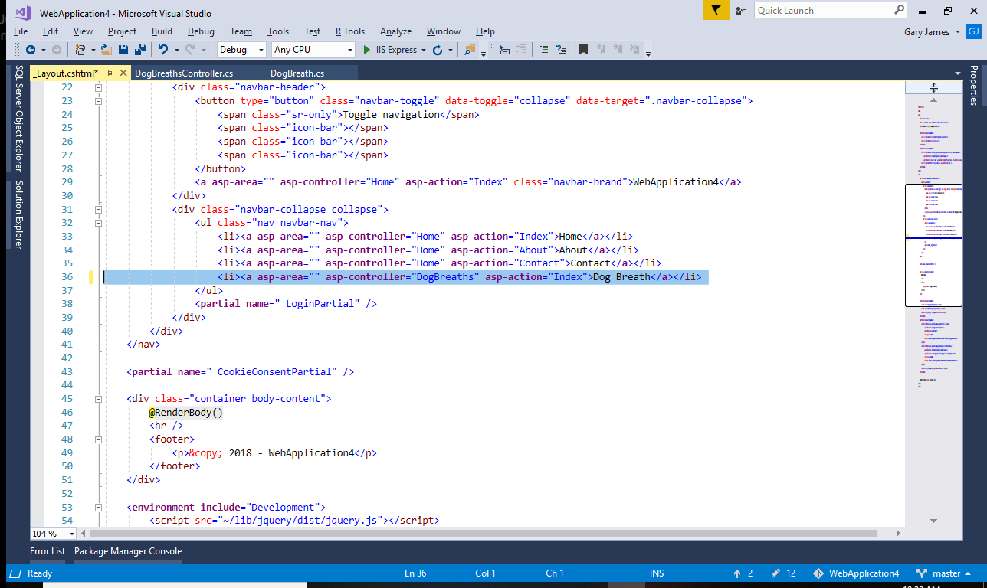

Over in ApplicationDbConext.cs is where our variable is that will hold our list of database objects. We like to follow the standard of giving this variable a plural name. When you change it to a plural word a light bulb will appear to let you change all of your code that uses this variable to use the plural name.

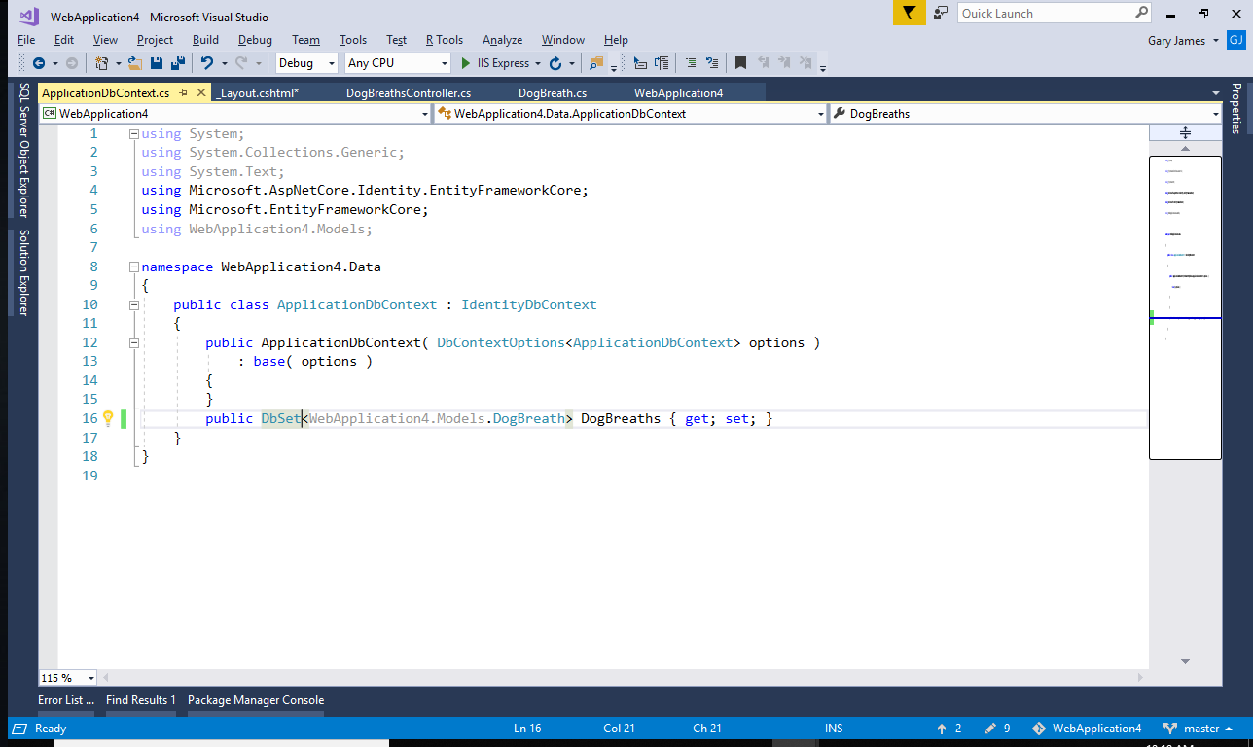

Add-migration initial

Update-database